Submission by (your name) re AIB prevailing rate

On [date], I signed up for a mortgage product where the initial rate was fixed for x years.
The mortgage contract contained the following clause 3.2
“At the end of any fixed interest rate period, the customer may choose between:
- A further fixed interest rate period, or
- Conversion to a variable interest rate Mortgage Loan, or
- Conversion to a tracker interest rate Mortgage Loan,
at the bank’s then prevailing rates appropriate to the Mortgage Loan.”
Up until October 2008, when borrowers rolled off their fixed terms, they were indeed offered this choice.
So AIB were contractually obliged to offer me those choices including the then prevailing tracker rate when my fixed rate period expired. But they did not do so.

AIB did have a prevailing rate when my fixed rate ended but they did not offer it to me
AIB argues that they had withdrawn tracker rates and so no longer had a prevailing rate
In their Redress Letter AIB said
“…when your fixed rate period expired, we had withdrawn tracker rates…”
AIB were entitled to withdraw tracker rates for new mortgage applicants but they were not entitled to withdraw the prevailing tracker rate for existing customers rolling off fixed rates. They were wrong to stop offering this rate to existing customers. That was a breach of an inherent and fundamental element of the contract.
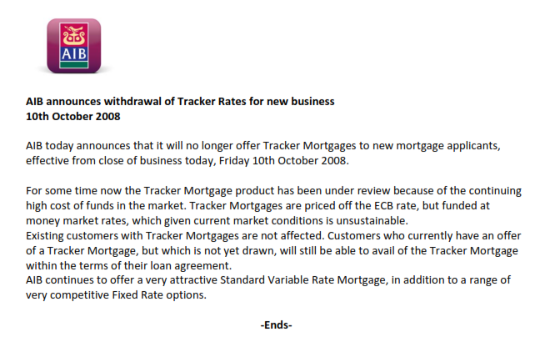

The press release did not refer to the cohort of customers who had drawn down their mortgages on fixed rates who had a right to be offered a tracker. There was no need to make such a reference as their right to the choice of a tracker rate was not affected by AIB’s decision to stop offering the product to new customers.
In December 2013 AIB changed the then prevailing tracker rate for customers whose fixed rate period ended after that date, but they did not re-introduce the product for new mortgage applicants. It is very evident based on this that AIB clearly differentiates between the two cohorts of customers – new applicants for mortgages who have no rights to a tracker rate and existing customers rolling off fixed rates who do have a right to a tracker mortgage at the then prevailing rate.
AIB implies that the then prevailing rate means the rate on offer to new customers
AIB implies that because they no longer offered the tracker mortgage product to new customers that they no longer had a prevailing tracker rate for existing customers. This just does not follow.
The mortgage contract did not define “prevailing rate”. It certainly did not define it as the rate on offer to new customers.
There is simply nothing in my contract which links the then prevailing tracker rate to the rate on offer to new customers.
If it had been AIB’s intention that existing customers could only avail of tracker mortgage rates on expiry of their fixed term, if they were still offering them to new customers, then they should have explicitly said so in their terms and conditions.
Clause 3.2 should have read:
“c) conversion to a tracker interest rate Mortgage loan at the Bank’s then prevailing rate on offer to new customers, provided that that the bank is still offering trackers to new customers on that date. If the bank is no longer offering trackers to new customers, then you will not be offered a tracker rate at the end of the fixed rate period and you may choose between our standard variable rates and fixed rates, if they are available”

The history of the AIB prevailing rate
AIB introduced tracker mortgages in 2003. From time to time, AIB changed the prevailing tracker margins which they offered to customers rolling off fixed rates.
In June 2008 they increased the margin on tracker mortgages with LTVs in excess of 80% to 1.5%. They next changed this margin in December 2013.

My fixed rate ended in x , so as I had an LTV in excess of 80%, the then prevailing rate for my was ECB +1.5%. I should have been offered this rate.
AIB did not do so. So to fully redress me, they need to recalculate my mortgage from the date the fixed rate ended and refund the interest overcharged and pay me 15% of the overcharge as compensation.

AIB argues that they did not have a prevailing tracker rate to offer me when my fixed rate ended
AIB did actually have a prevailing rate and it was 1.5%
AIB argues that it is a matter of fact that they did not offer tracker mortgage rates to anyone after October 2008.
Just because AIB wrongly stopped offering customers the then prevailing rate does not mean that they stopped having a then prevailing rate.
The then prevailing tracker rate for existing customers did not vanish into thin air between October 2008 and December 2013. In October 2008, AIB withdrew the tracker rate products for new mortgage applicants, but the rate continued to prevail for existing customers, even if AIB wrongly stopped offering it to them.
If we accept AIB’s argument that they did not have a prevailing rate, the only reason they didn’t have one is because they broke their contractual obligations to all their customers in not offering a tracker rate. So AIB would be rewarded for breaking their contract. This would clearly be an absurd outcome.
AIB argues that they withrew the prevailing rate because it would have been prohibitively expensive
AIB were entitled to change the prevailing rate but they chose not to do so. They were not entitled to withdraw the rate.
That is the decision that they made at the time. They might regret that now, but they should not have punished me for it.
The 1.5% margin continued to prevail until AIB changed it in December 2013.

Summary and Conclusion
- AIB had a contractual obligation to offer me a tracker mortgage at the then prevailing rate
- They had a then prevailing tracker rate of 1.5% which prevailed from June 2008 until they changed it in December 2013
- AIB claims that they had no prevailing rate because they had withdrawn it for new customers. There is simply nothing in my contract which links the then prevailing tracker rate to the rate on offer to new customers.
- AIB claims: “We did not have a then prevailing tracker rate available to offer you.” What they should have said is: “We did not offer you the then prevailing tracker rate”.
If the Ombudsman agrees with my argument that AIB was wrong in not offering me the option of choosing the prevailing tracker rate and that they still had a prevailing tracker rate of ECB +1.5%, then AIB will be putting me back on a rate comparable with the average mortgage rates in the eurozone. For example, the average variable rate for new business as of February 2019 was 1.76%.
On the other hand, if the Ombudsman finds that although AIB broke their contract by not offering me a tracker mortgage rate, the Ombudsman agrees with AIB that they did not actually have a prevailing tracker rate when my fixed rate period ended and furthermore allows AIB to set the prevailing rate retrospectively at its sole discretion, the Ombudsman will be allowing AIB to charge me one of the highest mortgage rates in the eurozone. I would be paying the Standard Variable Rate of 3.15% today vs. the ECB average of 1.76%.
It cannot be right that a failure on AIB’s part can benefit them to such a huge extent at my expense.

