Draft response to AIB’s response to

Borrowers’ names:
Appeal Reference Number :
Dear members of the Independent Appeals Panel
We have two basic arguments
- AIB had an obligation to offer us the prevailing tracker rate
- The prevailing tracker rate did exist and it was 1.5%
AIB has sought to make this very complicated in their response to my appeal, and, in general, in their public pronouncements on the issue.
Although their actual position is hard to pin down as it keeps changing, they appear to be accepting that they had an obligation to offer us a prevailing tracker rate. It really does not matter whether they characterise this as a “service failure” or “breach of contract” so I think it’s fair to say that we and AIB are agreed and that this aspect of the matter is settled.
AIB has responded that they did not have a prevailing tracker rate on the date the fixed term ended and therefore they could not have offered it.
The Independent Appeals Panel will have to review this issue and there is simply no other conclusion which you can come to other than that there was a prevailing rate on that date.
There is a huge difference between the two following statements
“We did not have a prevailing tracker rate”
And
“We had a prevailing tracker rate but we did not offer it to you”
It is clear that the second statement is correct.
AIB launched their tracker mortgage in 2003. From time to time they changed the tracker margin as they were entitled to do. Here is the history of that margin as far as we can make out from the press releases.

In June 2008, AIB increased this margin to 1.5% for LTVs in excess of 80%. (Not the 1.25% we had in our initial appeal.) In December 2013 they changed it again to 4.91%.
The prevailing margin did not just vanish into thin air in the intervening period. Just because AIB reneged on their contract and did not offer it, does not mean that it no longer prevailed. It continued to prevail at 1.5% until AIB next changed.
Our fixed rate period expired in [put in date here] , when the prevailing rate was 1.5% and that is the rate we should have been offered.
Our responses to AIB’s specific responses

This is the point of our complaint. While they were fully entitled to stop offering the product to new mortgage applicants, they had no right to stop offering the then prevailing rate to existing customer like us who had a right to roll off our fixed rate onto the then prevailing tracker rate.
In their press statement from the time that they stopped offering new mortgage applicants tracker mortgages, they explicitly recognised this.
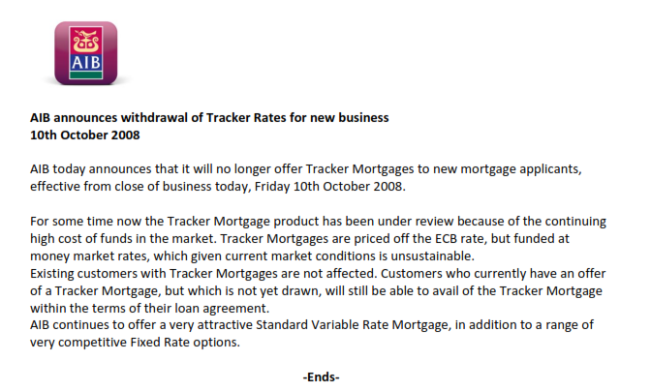
“AIB today announces that it will no longer offer Tracker Mortgages to new mortgage applicants”
This is a clear reference to new customers and new customers only. Of course they could not discontinue them for existing customers with a contractual right to be offered a tracker simply by issuing a press release. The choice of a tracker at the end of the fixed rate period was an inherent and fundamental part of our contract.
I also attach an undated letter issued shortly after October 2008 where again AIB confirms that
AIB had no legal right to withdraw trackers from those who had a contractual right to them.
In December 2013 AIB changed the then prevailing tracker rate for customers whose fixed rate period ended after that date, but they did not re-introduce the product for new mortgage applicants. It is very evident based on this that AIB clearly differentiates between the two cohorts of customers – new applicants for mortgages who have no right to a tracker rate and existing customers rolling off fixed rates who do have a right to a tracker mortgage at the then prevailing rate.

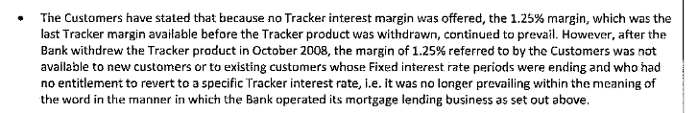
This makes no sense at all. We had a right to be offered the “then prevailing tracker rate” and that rate was 1.5%. AIB could have changed that rate at the time, but they did not do so. So while in 2008 we had no right in advance to a specific tracker rate three years later, when we rolled off our fixed rate, we did have a right to a specific tracker rate and that was the then prevailing rate of ECB +1.5%.
“it was no longer prevailing within the meaning of the word in the manner in which the Bank operated ins mortgage lending business…”
AIB did not define the terms “prevailing rate” or “prevailing margin” in their terms and conditions. They certainly cannot create a new definition 8 years later and impose it on the interpretation of our contract. As we pointed out in our appeal, if AIB wanted to define prevailing rate as the rate on offer to new business, then they would have had to explicitly state this in the contract. Clause 3.2 would have had to have read:
“c) conversion to a tracker interest rate Mortgage loan at the Bank’s then prevailing rate on offer to new customers, provided that that the bank is offering trackers to new customers on that date. If the bank is no longer offering trackers to new customers, then you will not be offered a tracker rate at the end of the fixed rate period and you may choose between our standard variable rates and fixed rates”
We do not see any ambiguity here. However, if the Appeals Panel does see some ambiguity in the meaning of this term, it is bound to interpret it in our favour according to the principle of contra proferentem.

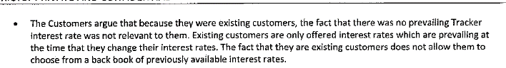
We most certainly are not making any such argument that “the fact that there was no prevailing Tracker rate”. This shows that AIB has simply not understood our argument. (We will assume that they are not deliberately twisting it.) We are arguing that there was a prevailing tracker rate. We pointed out that AIB’s withdrawal of the rate for new customers was of no relevance to us as we had a contractual right to the then prevailing rate.
We have not sought to choose from a back book of previously available rates. We only want our mortgage to be put on the “then prevailing rate” when our fixed rate term ended which was 1.5%.
This comes from Section 5 Summary of Appeal
We can’t see how our appeal can be interpreted in this way? We did not ever claim the rate which was offered when we became mortgage customers. We have only ever claimed the “then prevailing rate” when our fixed rate term expired.
They make other points about interest rates at time of drawdown. We have not referred to these rates at all.

